

PunchBugKIDS

**PunchBugKIDS connects with thousands of local parents in your local area.**

**Reach your target audience via one or more of our online advertising options.**

**FACEBOOK** $25 for a post plus a link to your website.

**Shout Outs** $30 for a one month posting of your Business, Sports or Summer Camp announcement our homepage.

**Open House** $30 for a one month Open House announcement on our homepage.

**Giveaway** Promote your products/services via a Giveaway posted on our homepage including your business information and URL link.

**Summer Splash** (January 10 through July 31)

$200 for: (1) a 6-month posting of your logo and link to your website, and exclusive PunchBugKIDS discount via our Summer Splash page, (2) a listing in the Summer Splash email blast, (3) a link to the Summer Splash page in the Events Email, (4) Facebook posts promoting Summer Splash several times throughout February, March, April, May, June and July and (5) one personalized Facebook post, specific to your Summer offerings and specials.

**Back to School Splash** (August through October) $100 for: (1) a 3-month posting of your logo and link to your website, and exclusive PunchBugKIDS discount via our Back-to-School Splash page, (2) a listing in the Back-to-School email blast, (3) a link to the Back-to-School Splash page in the Events Email, (4) Facebook posts promoting Splash twice during the months of August/September/October and (5) one personalized Facebook post, specific to your offerings and specials.

**Holiday Splash** (November-January 5)

$100 for: (1) a 3-month posting of your logo and link to your website, and exclusive PunchBugKIDS discount via our Holiday Splash page, (2) a listing in the Holiday email blast, (3) a link to the Holiday Splash page in the Events Email, (4) Facebook posts promoting Splash twice during the months of November/December/January and (5) one personalized Facebook post, specific to your offerings and specials.

**Splash Email blast Sponsorship** $100 for graphic ad in top right corner as Sponsor of specific Splash Email Blast to thousands of weekly subscribers.

**Premier Business Listing** $100/year for (1) a small graphic and short description under your resource listing/s in our online directory and (2) larger version of the graphic and longer description of your services under your business page (maximum 1,000 characters.)

**Events Email** $50 for 4 consecutive weeks of a graphic banner ad with a link to your website in our Events Email.

**Events Email Sponsorship** $100 for 4 weeks of a graphic ad in top right corner as Sponsor of the Events Email to thousands of weekly subscribers.

**A LOOK AHEAD** $50 to feature your event up to a full month prior to your event in our special “A Look Ahead” section on our homepage.



PunchBugKIDS

**Banner Advertisement**

We provide a variety of site-wide graphic advertisement packages for [www.punchbugkids.com](http://www.punchbugkids.com/) with a direct link to your URL page. We offer discounted rates for longer time commitments.

* Slider (1200 pixels wide x 351 pixel tall) for $200 month
* Medium Rectangle Level 1 (300 pixels wide x 250 pixels tall) for $75 month
* Medium Rectangle Stacked (300 pixels wide x 250 pixels tall) for $50 month

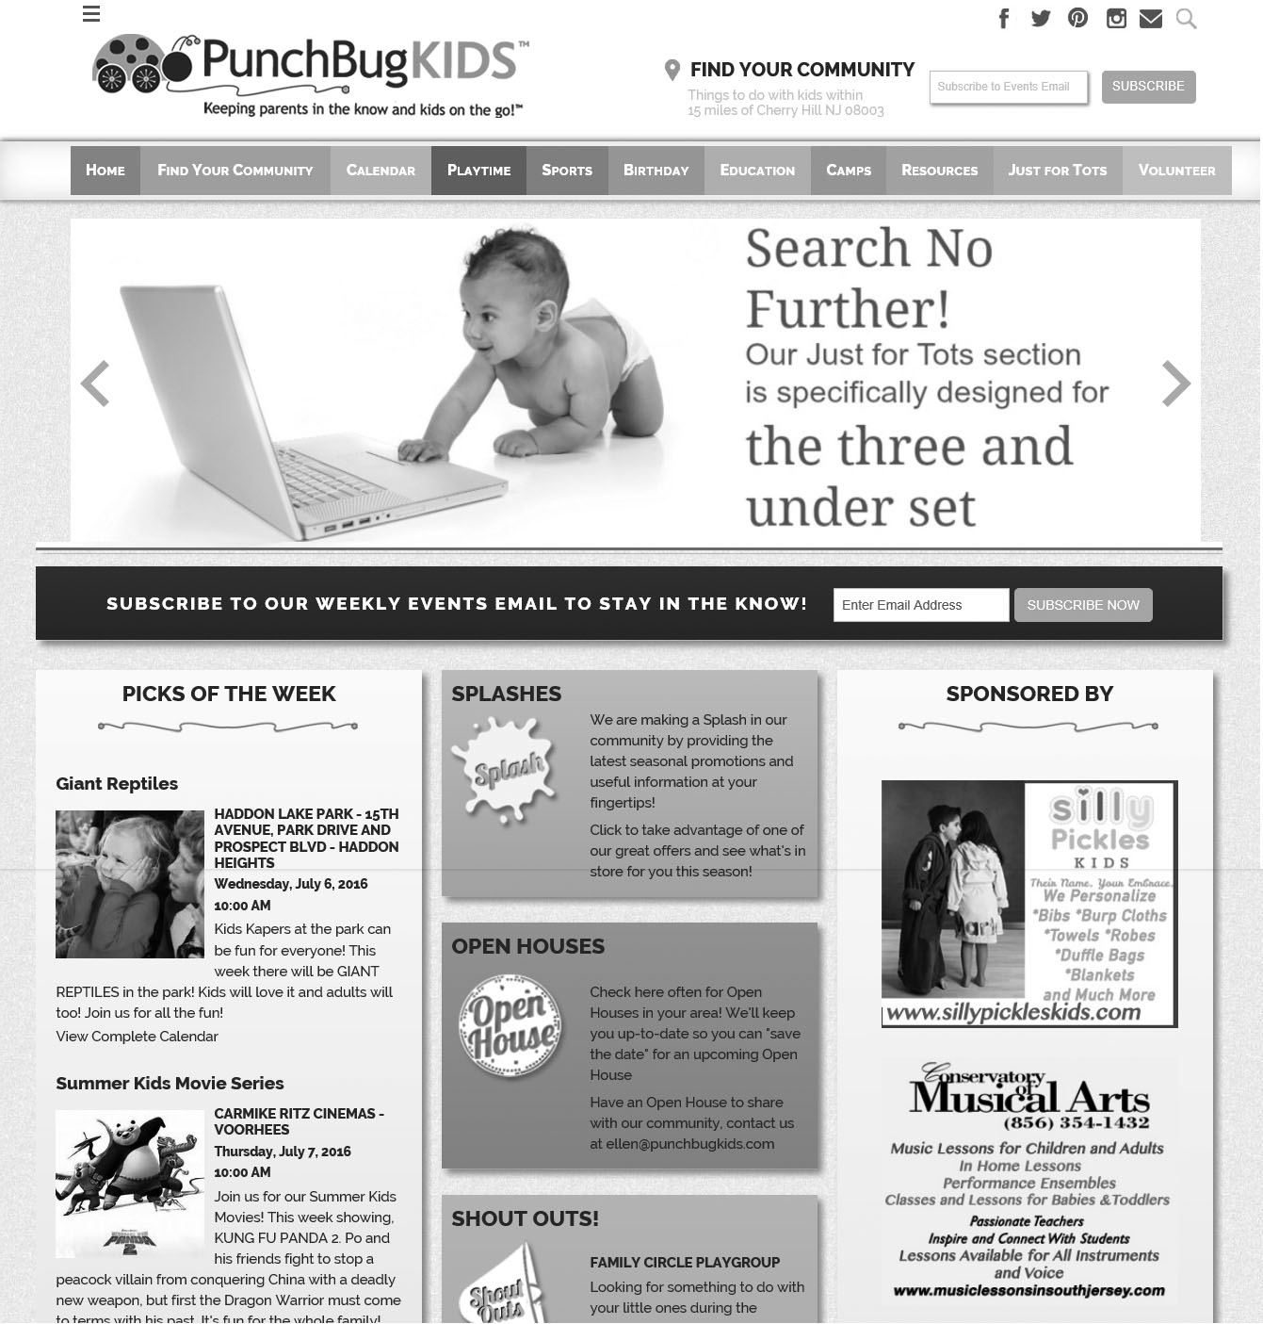

300 px

x

250 px

300 px

x

250 px



**aD content/format**

Advertisers are bound by our Terms & Conditions as defined and attached to our PunchBugKIDS invoice for services. Such Terms & Conditions and invoice comprise our Advertising Agreement.

Advertiser, and related agencies, are responsible for all content of ads and each agrees to indemnify and hold harmless PunchBugKIDS, LLC, their officers, employees, agents and independent contractors from and against all claims, liabilities, actions and losses arising from the ad usage. Additionally, PunchBugKIDS reserves the right to refuse any ad or service to any individual, firm, company or organization.

The Advertiser retains the right to give approval of all produced materials before an ad is placed. The failure of Advertiser to approve or disapprove within 2-days of submitting the materials to PunchBugKIDS shall be deemed the approval thereof by Advertiser. Once approval is granted (or deemed granted) by Advertiser, no changes will be made to the ad content. When an Advertiser provides an ad, PunchBugKIDS will use all reasonable caution to protect such ad and will not be liable for any loss or damage. All submitted ads need to conform to the exact stated mechanical conditions described by PunchBugKIDS, if not, PunchBugKIDS has the right to alter the ad.

All graphic ads intended for the Website and Events Emails are required to be in JPEG format, sized to 300 pixels wide x 250 pixels high (unless otherwise stated) with fonts embedded and saved at 300 dpi in RGB format. Only one link per graphic ad is permitted. Animated graphics may be placed on the website, but are not compatible with the Events Email. All website ads will provide a link to the Advertiser’s URL of choice. PunchBugKIDS reserves the right to alter the size of website ads to conform to changes in technology.

**payment/billing**

Payment is due upon receipt of invoice via our automated payment system. No advertisement will be published without prior payment.

**cancellations**

No cancellations will be effective after the date the approved ad is placed on the website without written agreement from PunchBugKIDS.

PunchBugKIDS