## Manual Part 3 - Adding Content, Business Listings

Getting started with your PunchBugKIDS site is super easy. We’ve got the site ready to go. All you need to do is load your local businesses and family-friendly events and you are up and running.

The first step is to create a list of local businesses to add to your site. We’ve got the resource categories set up for easy reference. You just need to fill in the blanks.

Start by using your own personal network of friends and family. You’ll find that people are always willing to share terrific resources they’ve learned about. Ask around, and you’ll quickly become your area’s expert on family-friendly resources.

Also, get out there and drive around. You’ll be surprised at how many family-friendly businesses are right there in your neighborhood. Pay attention to lawn signs, postings on bulletin boards in libraries and coffee shops, business cards and postcards at dance studios and doctor’s offices, etc.

The internet is your most useful research tool. Begin with a broad search -- for example, try <http://www.yellowpages.com> to start your basic search for local family-friendly businesses. Do searches by zip code (for example, museums near 08540) to find resources nearest you.

Check out your local competition to see what resources they list.

Once you have compiled your list of local businesses you will need to add them to your site.

Our most popular resource sections are Birthday, Playtime and Camps. You may want to start with loading those businesses first. Ideally you should have at least one resource listing for each section of your site.

Helpful Tip: As you are adding businesses to your site, take a moment to like them on Facebook as your Page.

**Adding Businesses**

To enter resources you must be logged in. Go to www.punchbugkids.com, select your local community and log in (at the bottom of your screen) **(1)**.

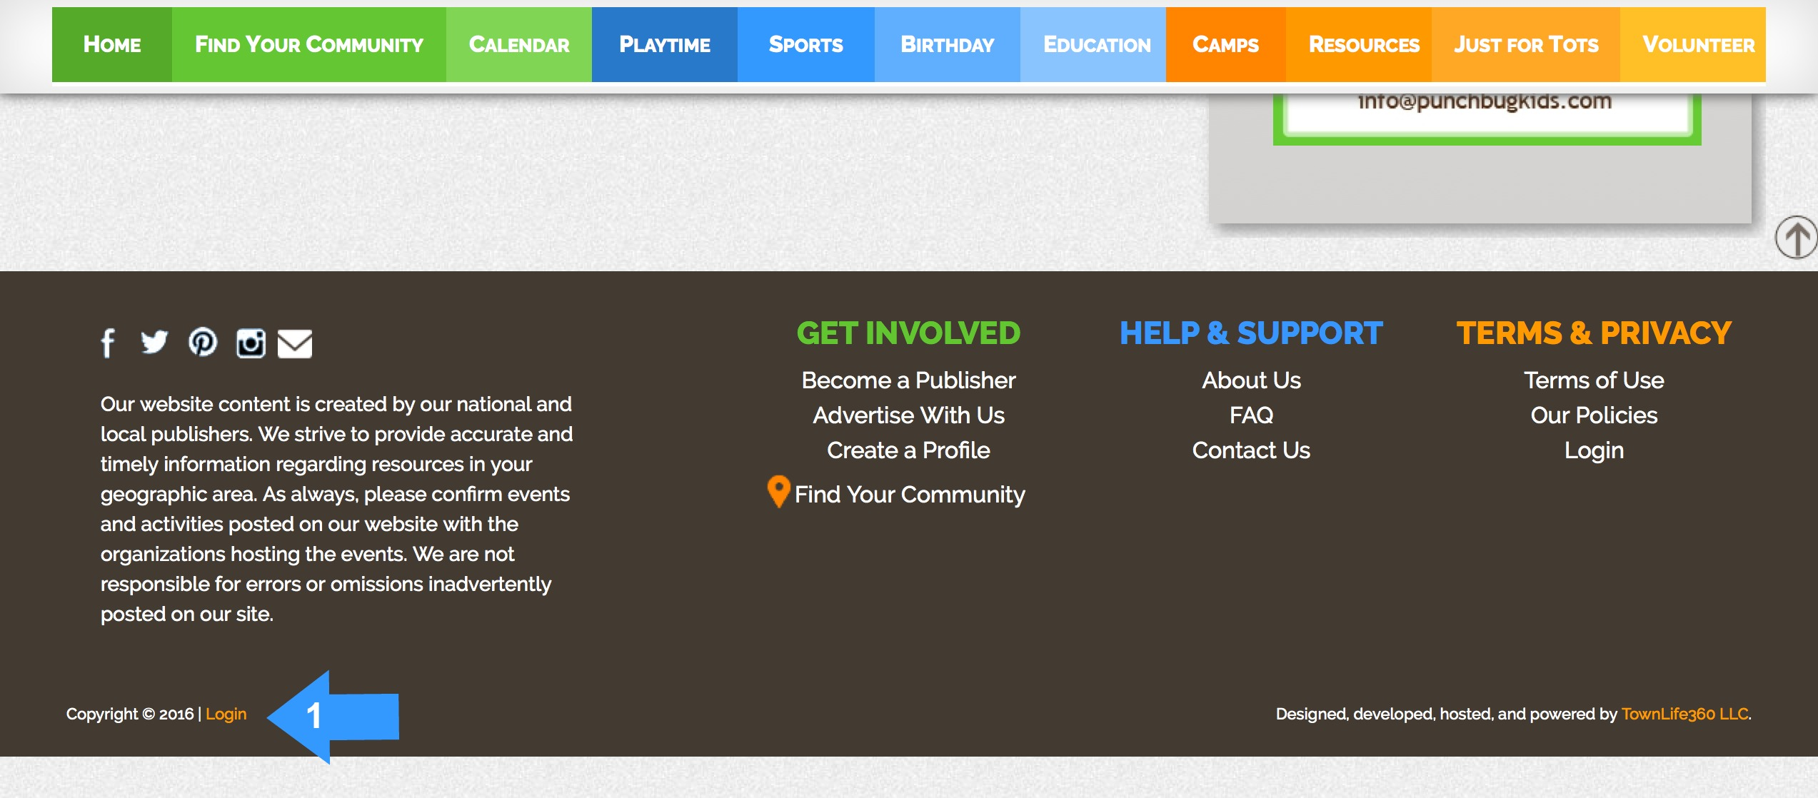

You add a new business to the site through your **Dashboard**.

At the bottom of the website click on “**Dashboard.**”

On the Dashboard you will find the “**Businesses**” section with two choices – “**Manage Businesses**” and “**New Businesses**.” To add a new business listing select “**Manage Businesses**.”

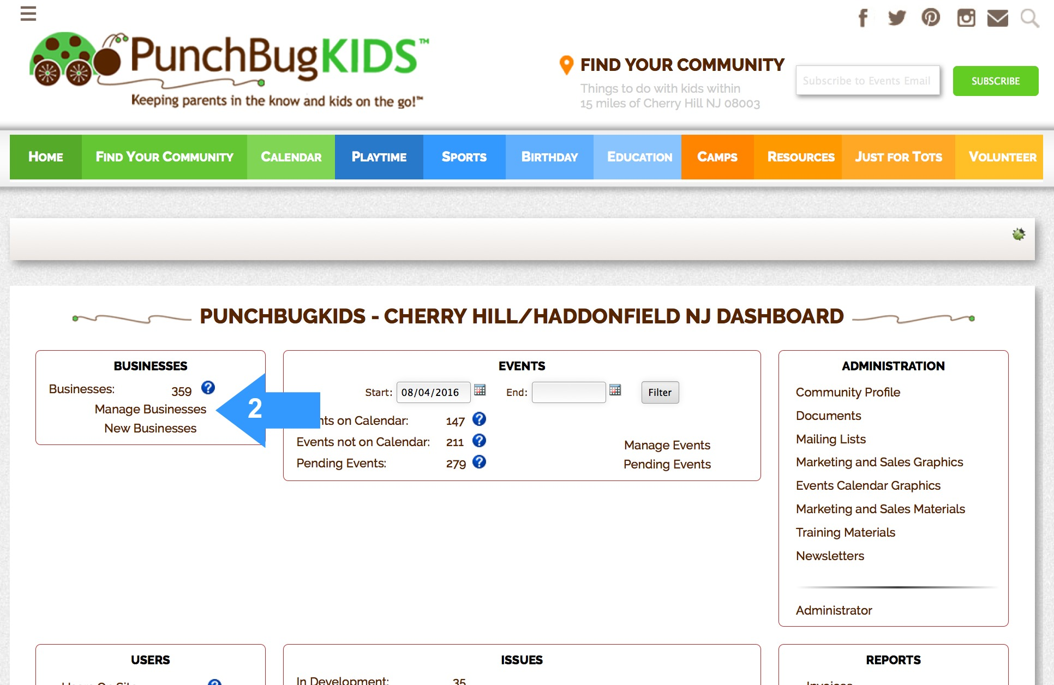

This will bring you to the “**Businesses**” page which looks like this:

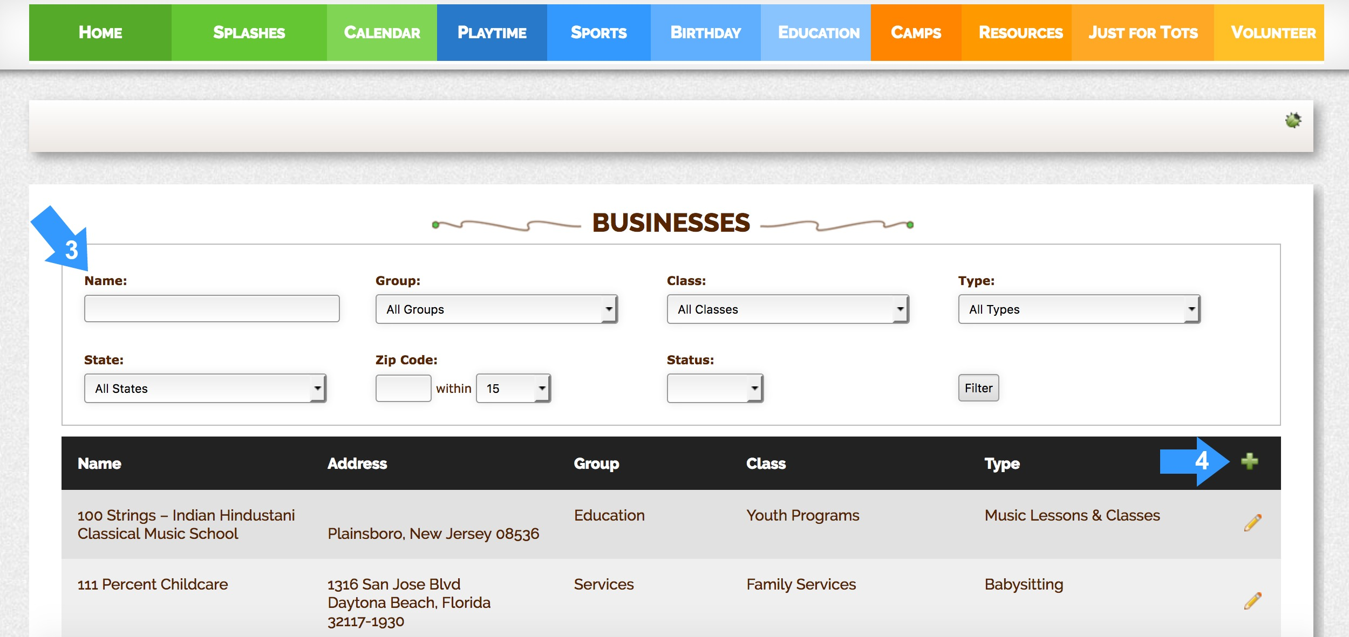

In the top left search box, type in the name of the business you want to add to make sure it’s not already in our database. **(3)** Be sure to use the correct spelling or it will not pop up. Be sure to leave the defaults set to search All States, All Groups, All Classes and All Types. Delete the zip code so that you can search the entire PunchBugKIDS database.*** Then click the “**Filter**” button to search. Do not click return or your search will revert to empty search boxes. If the business exists it will show up in the list below the search boxes.

***Please note, your search radius will default to a 15 mile from your main zip code. If the business you are searching for is a greater distance away, it will not appear in your search results. Thus, you want to remove the zip code so that you search the entire site.

1. If you find the business listed in our database check to see if it’s associated with the correct Group, Class and Type you would like it to be listed in. If not, you may click the “pencil” icon to edit the listing. You may select more than one “**Business Type**” to add to the business. (see details below)

2. If you do not find the business listed in our database you can add it by clicking the green + icon on the right side of the page to add a new business. **(4)** You will come to the “**Add Business**” screen which looks like this:

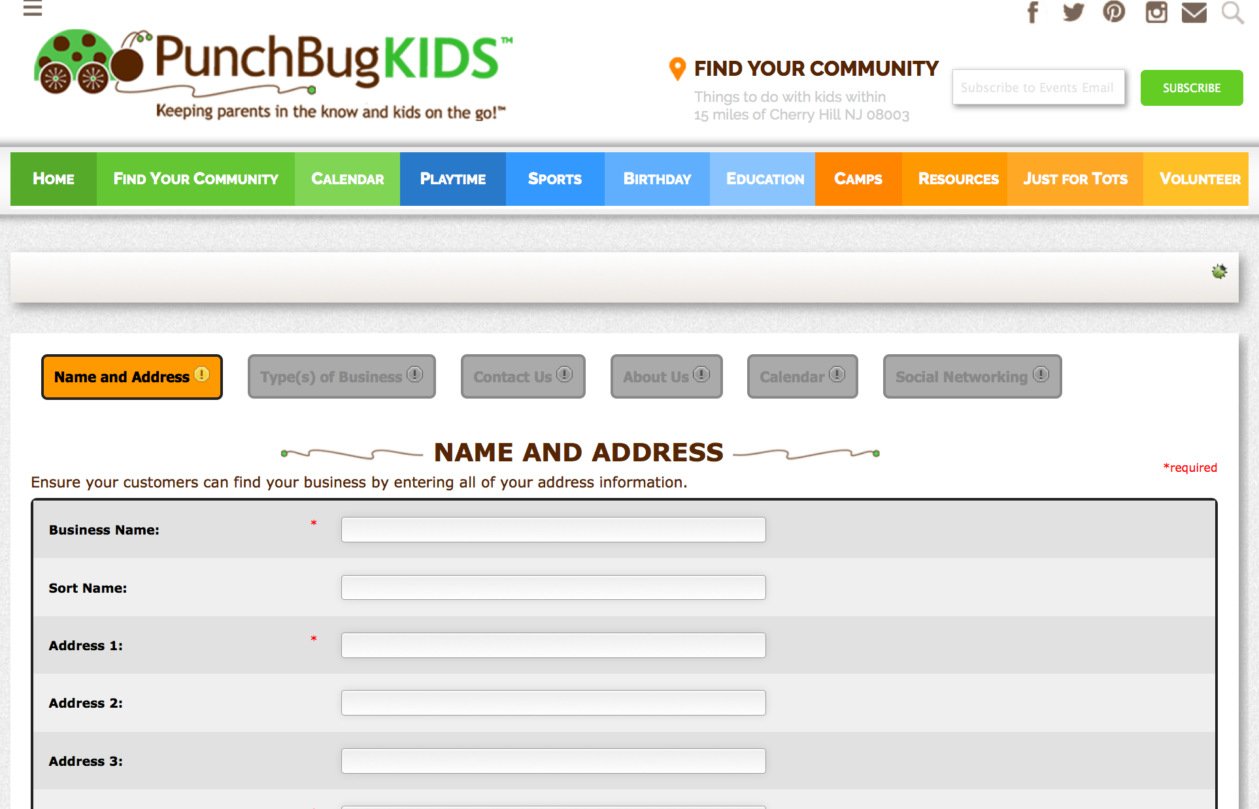

First you must enter the **Name and Address** for the business listing. The red asterisks next to certain fields indicate the fields that are required to be entered in our system to create uniformity in our listings.

3. Start by entering the correct business name in the “**Business Name**” field. The name should reflect how you want to business listed on your site. For example “Bounce U” or “Dr. John Smith, MD”

4. If desired enter a “**Sort Name**” for the business. It is not necessary to enter any information in this field. For example, the entry for “Bounce U” will be listed in proper alphabetical order so does not need a sort name. However, the listing for “Dr. John Smith, MD” will need a sort name of “Smith, John” in order for it to appear in alphabetical order in your resource section.

5. Enter the business contact information including street “**Address 1,**” “**City,**” “**State,**” and “**Zip Code.**” At a minimum you must enter zip code in order for your listing to appear on your site. We must have an accurate longitude and latitude (which is automatically generated behind the scenes) for all listings.

When adding resources it is important to strive for consistency. Your site will look best when it has a clean and consistent look to it. Please do not use abbreviations in the addresses. Write “Street” not “St.” and “Boulevard” not “Blvd.”

You do not have to enter the Active and Inactive dates. Click “**Save and Continue**.”

6. Next enter the “**Type(s) of Business**” for the business listing. Simply scroll through and check the box(es) for the correct business types associated with your listing. It is imperative that you indicate where the business listing should appear on your site.

You must select at least one business type for your listing in order for it to appear on the site. However, keep in mind it is possible to select multiple business types for your business. In fact you should select every possible business type so that your listing will populate every appropriate resource page. For example, a Chuck-E-Cheese’s restaurant should be entered under the business types “**Food and Dining – Kid Friendly**” to appear on our Family Friendly Restaurant resource page and “**Services – Event Planners, People and Places – Birthday Party Venues**” for our Birthday Venues resource page.

Each resource page on our site has pre-selected business types associated with it. For example, our page for “**Private Schools**” will list any business with the business types “Boarding Schools, Catholic Schools and/or Private Schools” selected.

When entering a business that’s a private school, you will obviously select the business type “**Private Schools**.” (found in the “**Business Types”** menu under “**Education – Schools**”) But, you may also want that business to appear on the “**Camps – Day Camps**” page. Thus you would also need to select the business type Day Camps. (found in the “**Business Types**” menu under “**Education – Summer Camps – Day Camps**”)

You will need to familiarize yourself with the business types to figure out what resources they should be paired with. For example, a waterpark under the category “**Playtime – Indoor Fun – Water Parks**” would be associated with the business type “**Arts and Entertainment - Recreation and Other Fun Things To Do –Waterparks – Indoor**.” It’s not always 100% intuitive, so you have to search through the business types to find the one that best fits your business.

If you do not find an appropriate business type but you need to add the business to our database in order to create an invoice or event for the business, you may select the business type “**Miscellaneous – Youth Miscellaneous**.” Please note that by selecting this business type your listing will not appear on our resource pages, it will simply be created in our database as an existing business.

Once you have selected all the appropriate business types associated with the business listing click on “**Save and Continue**”

7. In the “**Contact Us**” page enter the “**Phone**” and “**URL**” for the business. Try to link to the most direct source and keep the url simple. For example, link to [www.mccarter.org](http://www.mccarter.org) instead of <http://www.mccarter.org/home.aspx?page_id=1>. When adding the url you can either start with “**http://**” **https://** or “[**www.**](http://www.)” the site will automatically format the url for you. When desired you may also enter the “Fax” and “Email” for the business. Click “**Save and Continue**” to provide additional information or click “**Save and Finish**” to enter the listing in our system.

8. If you clicked “**Save and Continue**” you will be able to add content to the “**About Us**” section. Since we want Publishers to have a “voice” we have created the ability to enter phrases in the system. You may choose to enter “**Admission Prices**,” “**Hours of Operation**,” and “**Age Ranges**” to provide more detailed information for a listing. However, we strongly recommend only entering this information for businesses which are associated with only one of the business types. For example, when entering information for a Dance Studio you may elect to enter “**Age Ranges**” for the lessons. Keep in mind that whatever you enter in this field (as well as all the other fields in your business listing) will show up throughout your site every time the listing appears.

Thus, if you list your local YMCA as offering Dance Lessons and you add under “**Age Ranges**” - “3 and up”- that note will also show when the same YMCA listing appears for Basketball Lessons, Day Camps, Swimming Lessons etc.

Additionally, if you enter information in one of these fields be sure to remain consistent. Either say “3 and up” or “3 and older.” Pick one and stick with it through out your site.

We have left the section “**Brief Description of Business**” available for you to write free form about the listing. Try to be consistent in what you put in this field for each Category. For example, for a Dance Studio you may want to list the types of classes offered—again keep it simple and consistent throughout the section. Write “Ballet, Jazz, Tap.”

Again, as before, whatever you enter in this field (as well as all the other fields in your business listing) will show up throughout your site every time the listing appears. For business listings that appear multiple times throughout your site, **less is best**. Simply do not enter an additional description under “**Brief Description of Business**” or do not enter “**Age Ranges**” unless it is applicable to all the categories under which the listing will appear.

If you absolutely must enter additional information for a business, associated with multiple business types, and the information is not applicable to each business type, you may create a new and separate business listing. (However, you want to avoid doing so since the concept behind this data entry system is to keep it efficient for the data entry person. Your goal is to have each business listed once, not multiple times)

Do not enter information in the “**Long Description of Business**” box. This box is used our premier business listings. (See **Manual Part 4.7 – Advertisement, Premier Business Listings**)

Click “**Save and Finish**.” Do not move on to the “**Social Networking**” page. At this time this content will not appear on our site.

Please note an alternative way to add a business to your site is through the round, orange “**Add New Business**” button at the top of each resource page. This method is intended for the users of your site to submit a new business listing. As a Publisher, do not use this method to add a business as it will skip the important step of checking to see whether the business is already in our database. When a user submits a business, the Publisher will review the submission before activating the business listing. (See **New Businesses** below)

**Troubleshooting**

If you do not see your business listing appear on your site:

1. The business could be located outside the default mileage distance of 15 miles from your zip code. Search for the business without a zip code and see if it appears.
2. Make sure you have the business listing connected to the correct “**Business Types**” on the “**Add Business – Type(s) of Business**” page.
3. Make sure you have a correct and identifiable mailing address listed in your business listing. For example, the “**Address 1**” field cannot have a shopping center name listed or “Suite” listed. Usually such entries will result in an unidentifiable location for our search engine and thus your listing will not appear.

To make sure your address is correct, check the “**Find on Google Maps**” link on the “**Add Business – Name and Address**” page. Check where the location appears on the map. If it is incorrect, edit the business listing and click the “Edit Latitude and Longitude” check box. Here you can manually change the GPS address. Once edited, “Save” the business listing. This will reset the GPS coordinates for your listing.

**Manage Businesses**

As indicated above, you may edit a business listing from your “**Dashboard**” via the “**Manage Businesses**” function. From the “**Businesses**” page you simply search for the business listing you would like to edit. Once the business pops up under the search fields, a quick glance will let you view the “**Name**,” “**Address**,” “**Group**,” “**Class**,” and “**Type**” for each business listing. This is a short cut way to check the address or to determine whether all the correct Business Types are associated with a particular business. Click the “pencil” icon to edit the business listing.

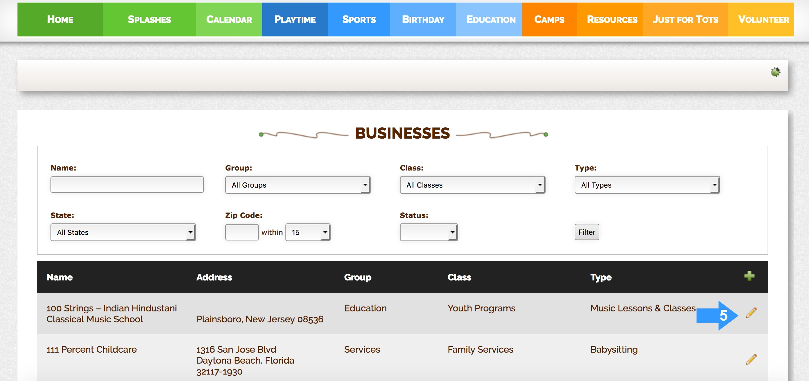

We do not allow you to delete a business listing. Please de-select all business types from a business by editing the listing to remove the listing from your site. This will leave the business in our database for future use.

You can also edit a business listing from the business’ Business page (“**the B-page**”). To find a business’ B-page simply search for the business in the resource sections and click on the business name.

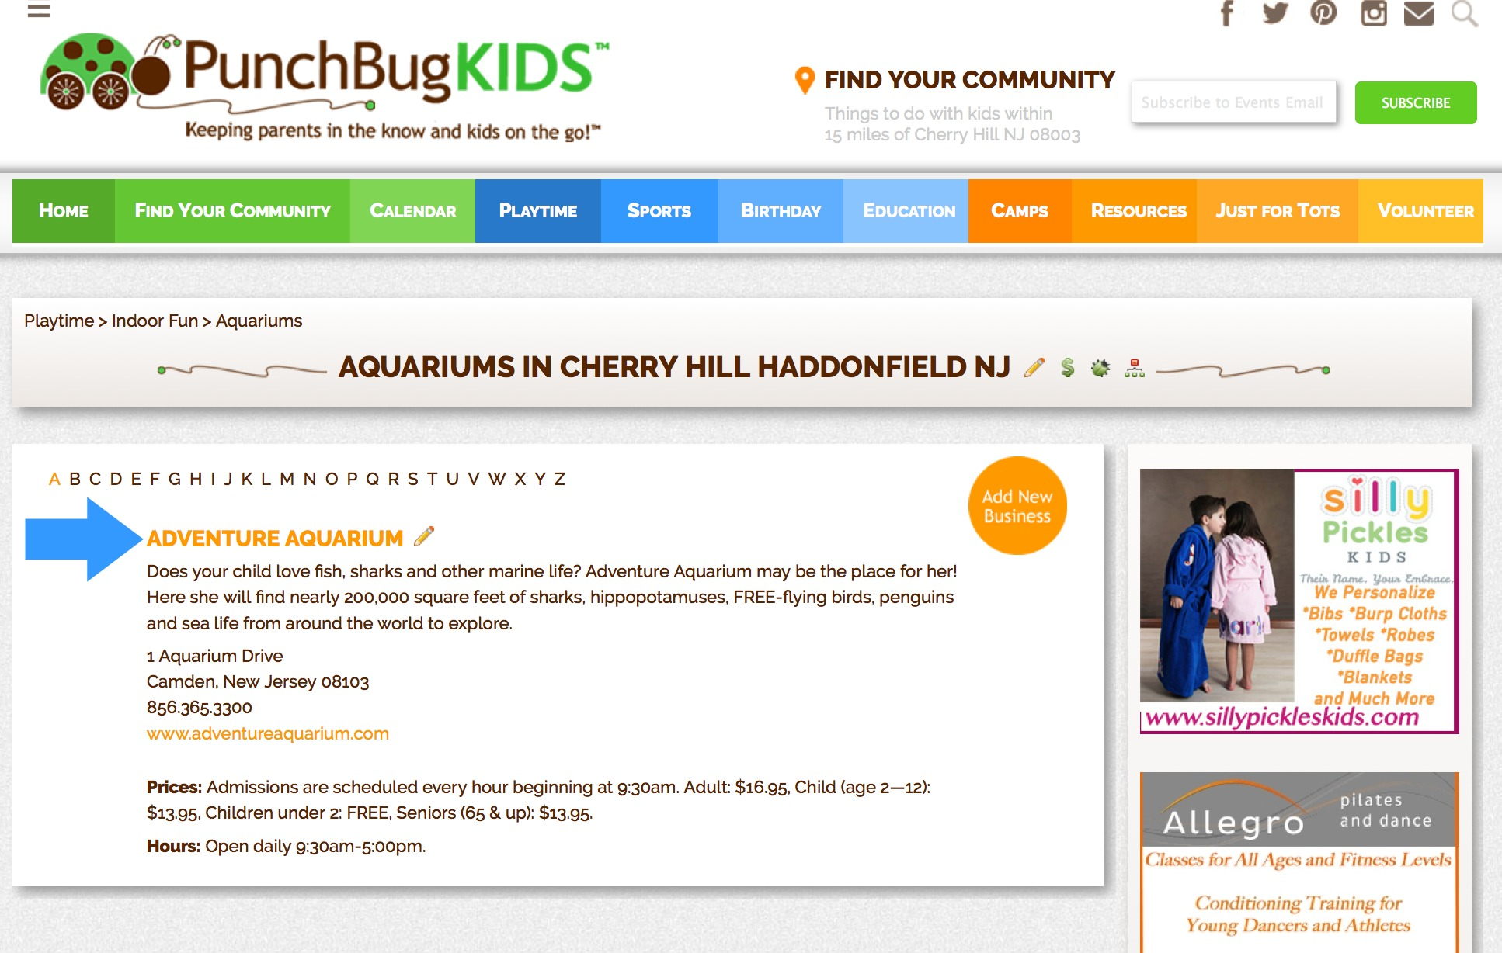

You will be directed to the B-page for that business. From here you can Add and Manage Events, Manage Documents, Manage Ads and Edit the listing as will be described in further detail in this Manual.

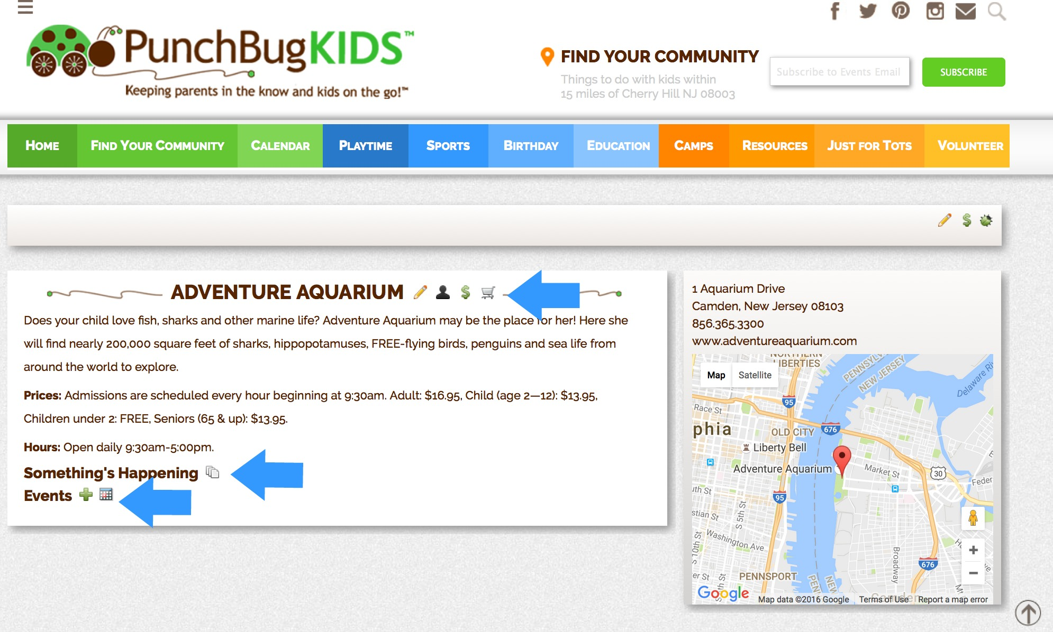

**New Businesses**

Site users will be able to submit new business listings for your site. You must approve these submissions before they will appear on your site. These can be found on your Dashboard under “**Businesses,**” “**New Businesses.**” Here you will find a list of submitted business listings waiting for approval. The screen will look like this:

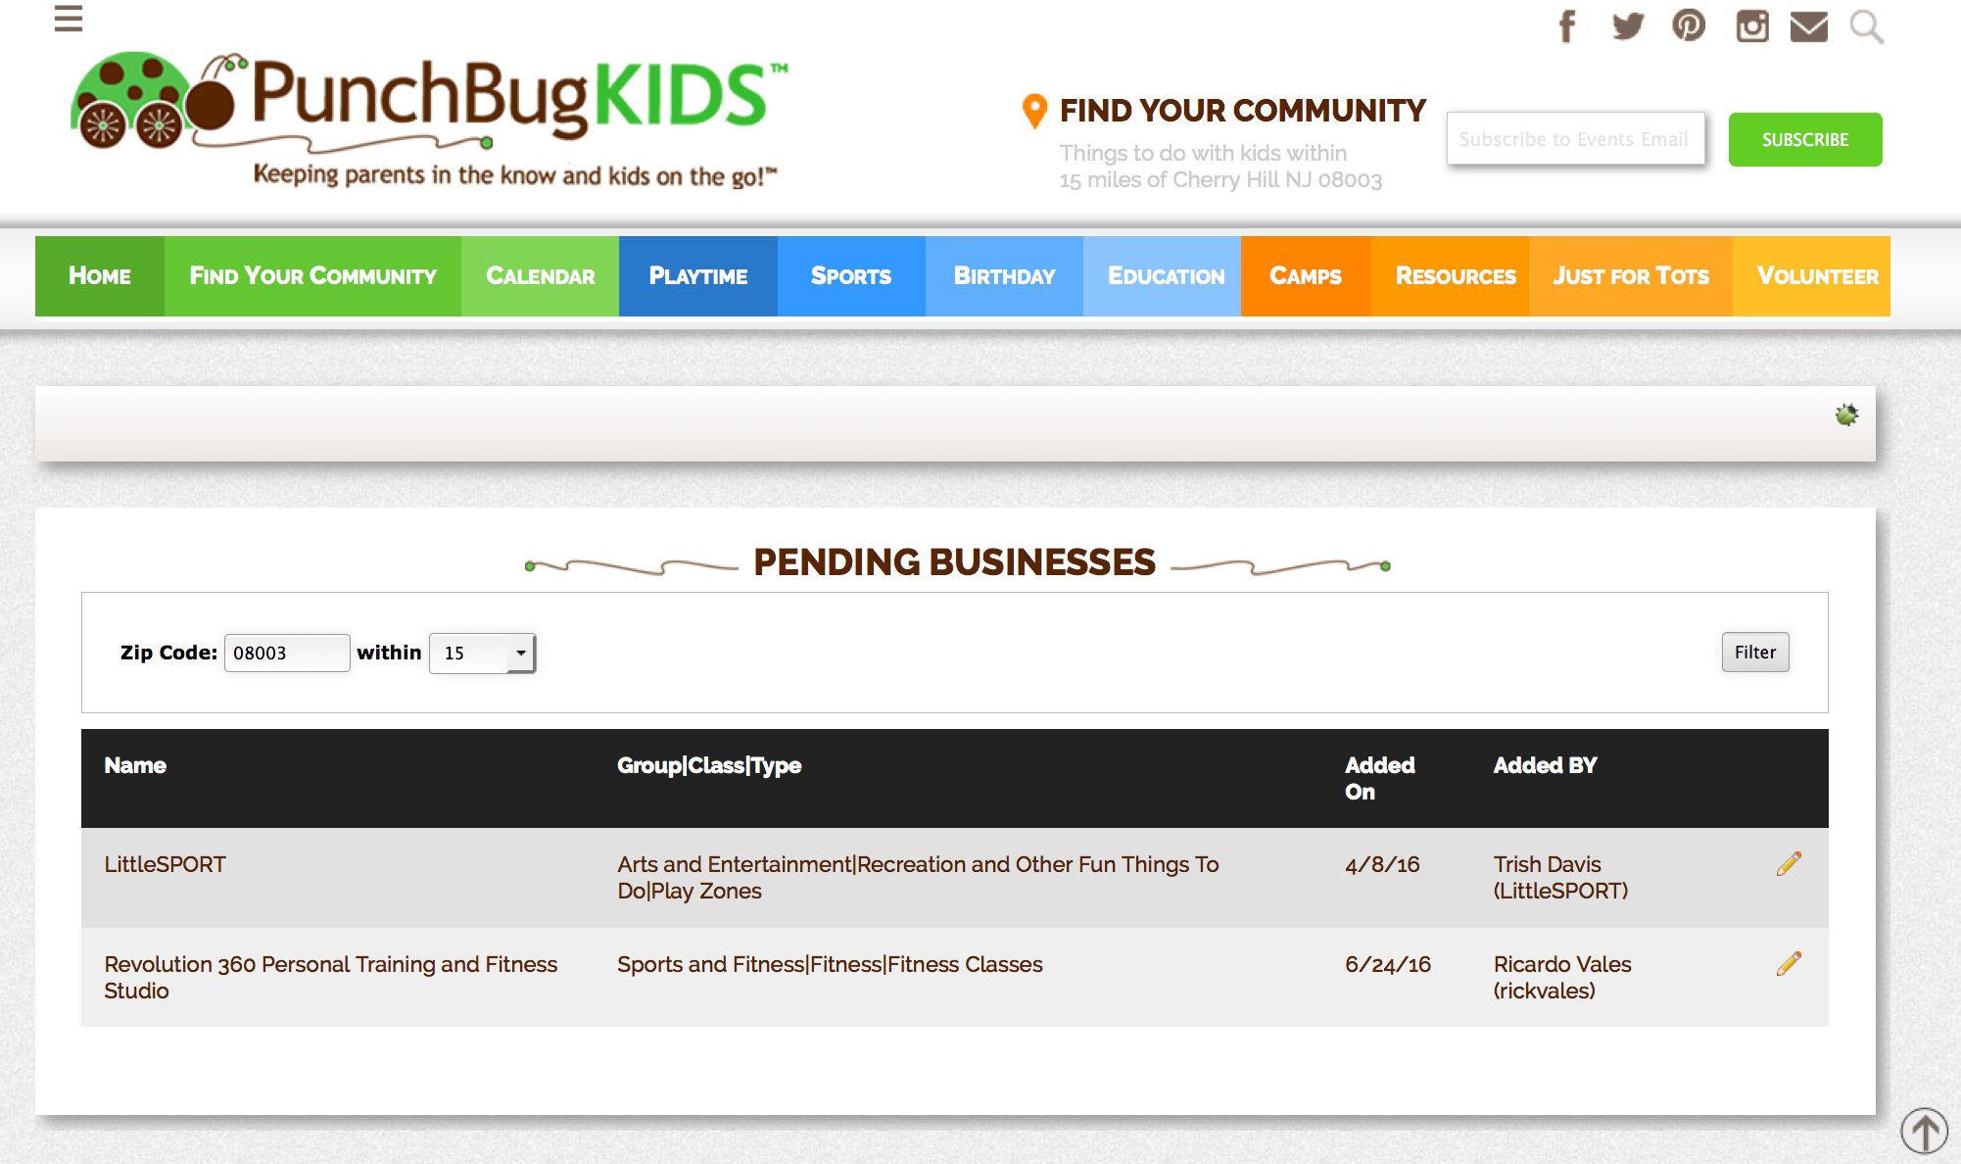

Click the pencil icon of the business you are reviewing to edit the listing. The next screen will take you to the “**Approve Pending Business**” page where the submitted information is listed. On the right side of the page you will see possible matches for pre-existing businesses in our system. Make sure the business is not already listed. If it is, you may select that business and edit the content of the listing.

At the bottom of the page you may choose to “**Approve**,” “**Delete**,” or “**Cancel**.” When you click “**Approve**” you will come to the “**Add Business**” page where you can edit the submitted information as discussed in the “**Adding Businesses**” section above. You must:

1. Confirm the correct information is supplied for the required fields, including the zip code.
2. Confirm the “**Type(s) of Business**” associated with the submitted business.
3. Ensure the fields for “**Admission Prices**,” “**Hours of Operation**,” “**Age Ranges**,” and “**Brief Description of Business**,” are filled out properly where appropriate.
4. Click “**Save.**”

The business listing should now be visible in the selected resource categories of your site.