**Manual Part 5 - Events Email**

You will be responsible to send out a weekly events email called “The Punch List.” It is a high quality, FREE service that we provide to our email subscribers on a weekly basis.

**What is The Punch List?**

The Punch List is a weekly email that contains local, family-friendly activities and events. It is essentially a current week’s worth of activities and events downloaded from your PunchBugKIDS calendar and loaded into an email format. It is a FREE email for your subscribers which keeps them “in the know” on family-friendly activities in their community. It does take a little effort each week to create your email, but the benefits far outweigh the burden.

**How The Punch List Helps You**

Monetizing The Punch List and building a subscriber base are significant ways to increase the value of your business. Local companies want access to your email subscriber list—it is after all a database of local moms and dads (and other caregivers) in your community. Through your email you reach a specific target audience of families in your community on a weekly basis, which gives you (and potential advertisers) direct access to this elite group.

Your email subscriber list is valuable. You may not sell it.

However, you may sell advertising to local businesses in the form of graphic advertisement and sponsorships. The right side bar of the Punch List will automatically populate with invoiced events email advertising and events email sponsorships.

**Events Email Content**

The content of the Punch List is important. The Punch List is not junk mail. It is a valuable resource that “keeps parents in the know and kids on the go!” Subscribers come to depend on it to plan their upcoming week of family-friendly activities.

The content of the email is automatically pulled from your calendar. Therefore, please remember to only post activities and events that have a children’s component on your calendar of events. Do not post items such as parent lectures, school open houses, school auctions, etc. The main body of your email will feature a full week’s worth of activities and events.

Your email will feature Picks of the Week at the top of the email. When adding an event to your calendar you must select “Pick of the Week Email” in order for it to show up as a Pick of the Week in your weekly events email.

Use a Pick of the Week wisely. We do not sell these but rather use these to feature a favored event or activity. You may list more than one Pick of the Week, but try to limit yourself to 3 - 4 maximum. You should note that on average, more subscribers click on the Pick of the Week than other listings. Thus, this can be a perfect vehicle for trade or barter as well. Throw it in as a freebie to close a sale. (See **Picks of the Week**)

A Look Ahead is featured in your events email underneath the Picks of the Week section. It is an opportunity for your clients to feature an event up to a full month prior to their event.

In addition to the events, The Punch List is a great resource for self-promotion. This is the perfect vehicle to get your message out to your audience. Items such as links to Giveaways, Splash pages and Announcements should be posted in your email in the right-hand column underneath your advertisement. (See **Events Email Internal Promotions).**

You can also edit thetop brown content box of your email to include a personal note to your subscriber base.

Of course your email content should include paid advertising and sponsorships.

Finally, every email sent contains a Header (the branding for the email as well as links to our social media) and a Footer (the contact information for our company as well as an unsubscribe link).

**Mailing Lists**

Subscribers may sign up for your events email by entering their email address on the large brown “Subscribe to our Weekly Events Email” Bar prominently featured on your homepage. When they do so they will be added to your local Events Email mailing list.

In addition, subscribers may enter giveaways posted on your site. When they do so they will be added to that Giveaway’s mailing list as well as to your local Events Email mailing list.

To access your mailing lists, go to your Dashboard and click on “**Mailing Lists**.” Here you will find your local events email mailing list in addition to any Giveaway mailing lists and a test mailing list.

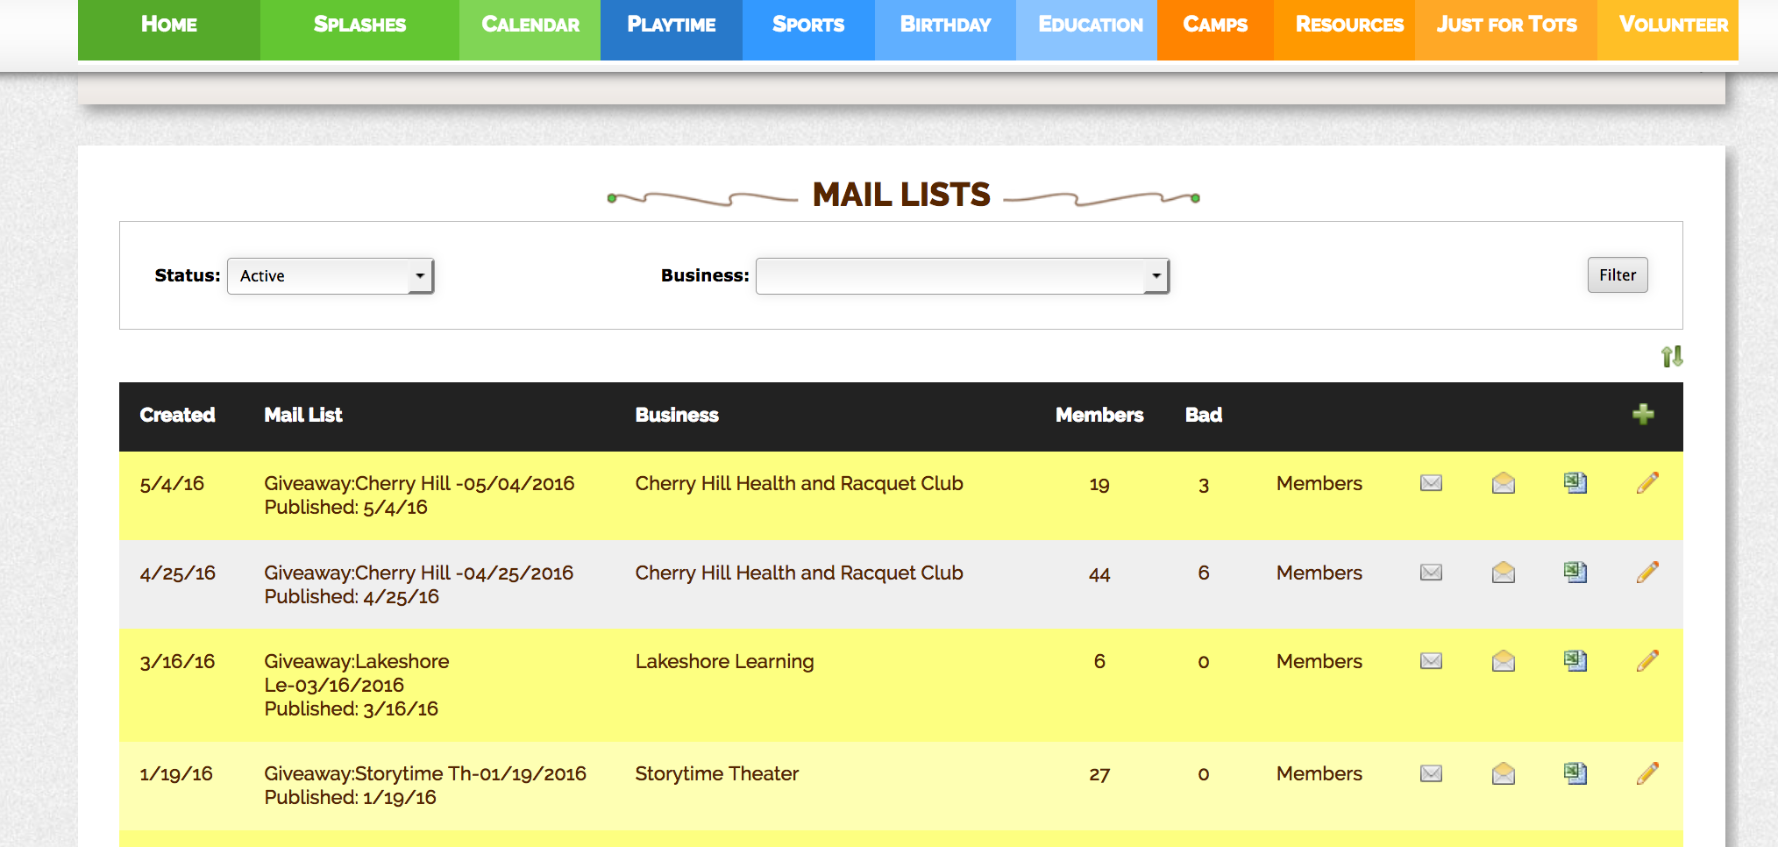

You can edit, export or email your mailing list by clicking the corresponding icons:



The pencil icon will allow you to edit the name of the mailing list.

The excel icon will allow you to export the mailing list in excel format.

The envelope will allow you to send an email to the entire mailing list.

By clicking on “**Members**” you can search for a subscriber by “**First**,” “**Last**” name and “**Email**” address. You can “**delete”** a subscriber by clicking the red circle or “**Opt Out”** a subscriber by clicking Opt Out. Deleting the subscriber simply deletes them from the mailing list. If the subscriber wants to be deleted from all communications (current mailing lists and future lists) you must select “Opt Out” for them.

Your mailing lists will become valuable assets for your business. Please remember that we do not sell this resource.

In addition to your local Events Email mailing list and your various Giveaway mailing lists, you will also have a Test mailing list. This is a mailing list addressed solely to you. You will use this to preview your emails prior to sending emails out to a larger audience.

**Getting Ready to Create and Send Your Events Email**

The process of creating and sending the Punch List is simple. First, choose a day and time that works for you. For example, you may wish to send your email every Wednesday at 1am. We have found that subscribers like waking up in the morning on Wednesday to find the email in their inbox. Don’t worry, our system allows you to schedule your email so that you can create it and schedule it to send out at a designated time. (you do not have to be awake at 1am!)

Second, pick a consistent title for your email. For example “Lower Bucks County Events Email for 9/4/18 – 9/10-18.” Each week only change the date range. It’s simple and consistent. Subscribers know exactly what it is when they see it in their inbox.

By creating a consistent time and title for your email, your subscribers will become accustomed to receiving the Punch List as part of their weekly routine.

**Creating the Punch List**

Go to the “**Administration**” panel of your **Dashboard** and click on “**Newsletters**.” Select the green + to create a new events email. From the “**Add Newsletter**” page you will check the box “**Generate Newsletter from selected Page:**” and you will select Events Email. (This selection dictates what content will populate your email)

Next enter a “**Start**” date and an “**End**” date to select the date range for your email content. You should select a 7-day date range.

Next “**Name**” your email. We would recommend keeping a consistent title. Name it “Lower Bucks County Events Email for 9/4/18 – 9/10-18.” Follow this format each week by simply changing out the dates.

Select your “**Mail List**.” You will initially select your Test email list so that you can send yourself a draft email to review before sending it to your entire subscriber database.

Finally, select the “**View**” for your email. You will select the “**PBK Events Email**” header. (This selection dictates what header that will appear at the top of your email.)

After you’ve made all your selections, click “**Save**.”

Now when you return to your “**Newsletters**” page you will find your email waiting for you in red highlight at the top of the page. The red highlight means that the email has not been sent yet.

**Editing the Punch List**  
You are now ready to edit the content of your email. To the right of your newly created email you will see the following icons:



The pencil is the Edit button

The screen is the Preview button

The envelope is the Email/Send button

Select the pencil to edit your email. At this point your will want to make any necessary changes to the formatting. Please double check that the correct information is presented in your email. You should have at least one Pick of the Week at the top of your email and a week’s worth of events in the body of your email. In addition, your Events Email advertisement should appear in the right side column of your email along with any links to your Giveaways and Splash pages. (See **Giveaways** and **Splashes**). You may also choose to edit the brown text box at the top of your email with a message to your subscribers. Simply click on the existing text and delete it and replace with your message.

You may choose to make corrections in the body of the email. However, if you are editing an event that is a recurring event you will want to make the edit on your calendar. Please return to your Dashboard and select “**Manage Events**” to edit the event. That way the same issue will not appear the following week when generating your next email.

If you make changes to the content of your email on your site (and not within the body of your email) you will need to re-generate your email to reload it with the newly edited content. Simply go back to the “**Newsletters**” page, select your email, click the edit icon and select the box for “**Re-Generate Newsletter from selected Page:**”

Continue to edit your email until you believe it is ready to send. Click “**Save**” to save your edits.

**Sending the Punch List**

Before sending your email to your entire subscriber database, you will want to preview your email.

From the “**Newsletters**” page simply select the Preview icon. You will not be able to edit from this screen.

Once you are satisfied that the email is ready to send, go back to your “**Newsletters**” page and select the Envelope icon. This will bring you to the “**Email Newsletter**” screen. Under “**From:**” you will select the correct email address to send the email from. This should be your PunchBugKIDS email address. This is the email subscribers will reply to if they choose to reply.

Under “**To:**” you should enter your Test mailing list.

Under “**Subject:**” it will automatically fill in the name of your email. Remember to use the same format each week for consistency, changing only the dates.

Next you may schedule a date and time to send your email. You can schedule it for any date and time in the future. For your test email back date the “**Schedule For:**” to send it immediately.

Scroll all the way to the bottom of the email content and click “**Email**.” You should receive a copy of the test email in your inbox immediately.

Once you have reviewed it you may repeat the steps above to send your email to your subscribers. When you return to the “**Newsletters**” page, your email will now appear in grey (since it has been sent). Follow the steps above to re-send the email to your subscribers. To do so, this time select your local Events Email mailing list for the “**To:**” box from the “**Email Newsletter**” page. You may schedule it to send at a later date or enter the current time in the “**Schedule For:**” box to send it right away. Click “**Email**” and you are good to go.

We send your email out in batches of 500 emails at a time. If you have a large number of subscribers in your mailing list it may take a few minutes before all the emails are sent. You will be able to track your emails on your “**Newsletters**” page. You will see if the email is “**Scheduled”** for a particular time, the “**Total**” emails to be sent, how many emails have been “**Sent**” how many emails have been “**Viewed**” and how many emails “**Failed”** to be delivered.

You may go back to your “**Newsletters”** page at anytime before your email is sent and cancel a scheduled email. To do so simply click on the red circle icon next to the scheduled time for the email and your request to send the email will be canceled. If you cancel an email while it is in the process of being sent, only the ones not yet sent will be canceled.

**Events Email Advertising**

There are three types of advertisements available for sale on your Events Email: Events Email Ads (graphic advertisements with a url link which appear on the right side banner of the email); Events Email Sponsorship Ads (graphic advertisement with a url link which appear in the top spot of the right side banner of the email) and A Look Ahead.

Adding Events Email Advertising to your email is easy. The process is entirely automated. Once you have sold an Events Email Ad; an Events Email Sponsorship Ad or A Look Ahead, you will invoice the client. Upon receipt of their payment you will be able to upload the client’s graphic ad and indicate the length of time the ad will run. (See **Manual Part 4.3 - Advertisement, Uploading Advertisement**).

It’s that simple. The advertisement will automatically load when you generate your email throughout the duration of their purchased advertisement. If you do not see your ad, you need to go to your Dashboard, click on “**Manage Businesses**,” search for the business and click on the dollar icon to manage your ads. Most likely you will need to change the date range for the ad to ensure it is running the correct length of time.

**Events Email Internal Promotions**

Promotion of your Giveaways and Splash pages is of upmost importance. To post these you will need to purchase an internal ad.

Go to your Dashboard’s Businesses panel and click on “**Manage Businesses**.” Conduct a search for your local PunchBugKIDS and select the business. From your PunchBugKIDS B-page click on the shopping cart icon, to purchase an Events Email Internal Ad. Set the actual value at $0, and proceed to check out. After you have submitted your $0 payment, click on View PunchBugKIDS and you will be back at your B-page.

Next, from the B-page click on the dollar icon to manage your ad. From the PunchBugKIDS Ads page you will see your Events Email Internal Ad highlighted in red. The red highlight means that the ad is not active. Click on the pencil icon to edit this ad. From the “**Edit Business Ad**” page you will add an image, url, Active and Inactive dates.

You will want to create an internal events email ad anytime you have a Splash or Giveaway posted on your site. The graphics for the Splashes and Giveaway are located on your Dashboard under **Administration - Marketing and Sales Graphics**. Whenever you have a Giveaway posted, you should purchase an internal ad for that duration of time. Upload the generic Giveaway graphic housed under your Dashboard’s “**Marketing and Sales Graphics**” and/or create your own giveaway graphic (300 x 250 pixels). Whenever you have a Splash promotion running you should purchase an internal ad for that duration of time. Upload the specific Splash graphic housed under your Dashboard’s “**Marketing and Sales Graphics.**”

The ads will appear under your paid advertising on the right hand side bar of your email, beneath your social media icons.

If you need to edit these, go to your local PunchBugKIDS B-page and click on the dollar icon to edit the ad.

**Few points to remember about The Punch List**

1. Your Events Email mailing list about quality, not quantity. The value behind this list is that each subscriber is a local caregiver in the community.
2. Each local PunchBugKIDS website has a “Subscribe to the Events Email” button prominently displayed on the homepage. You should post reminders about the email via social media outlets often.
3. The Events Email should go out consistently. Subscribers need to be able to depend on receiving the Punch List at a set day and time each week.
4. The Punch List should feature only family friendly activities and events. Do not include events that do not feature a child friendly component (for example, do not list parent lectures, school auctions etc.)
5. Use the Punch List to promote your own site including Giveaways and Splash pages via Internal Ads or via the brown text box at the top of your email.